**t-test**

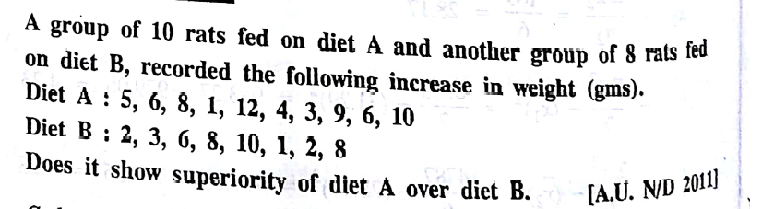

H0 : x1bar = x2bar  
H1 : x1bar > x2bar (Right tailed test)

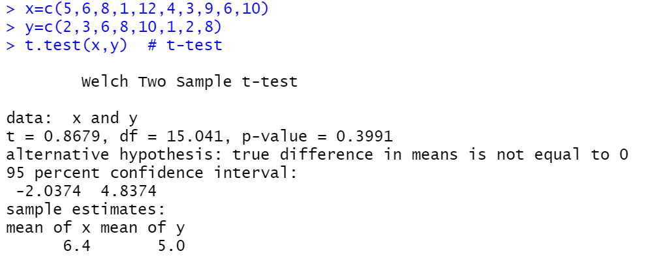  
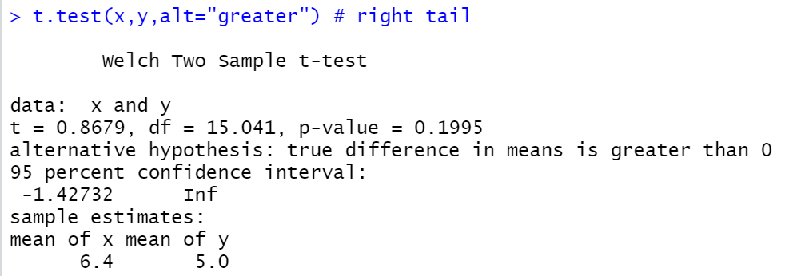



alpha 🡪 0.05  
p_value 🡪 0.1995

p_value>alpha, So H0 is accepted.

2)

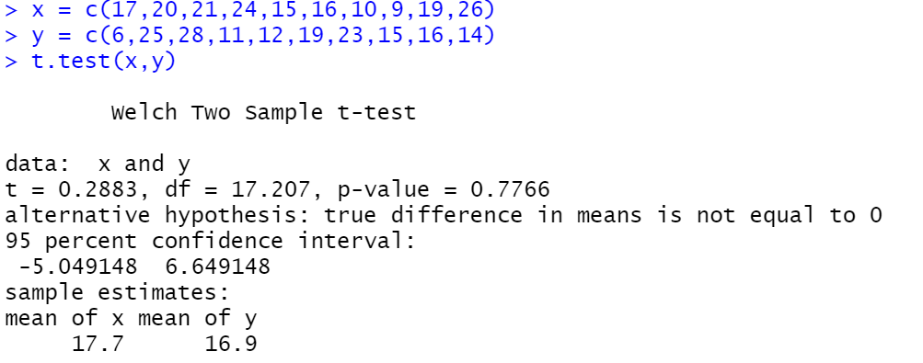  
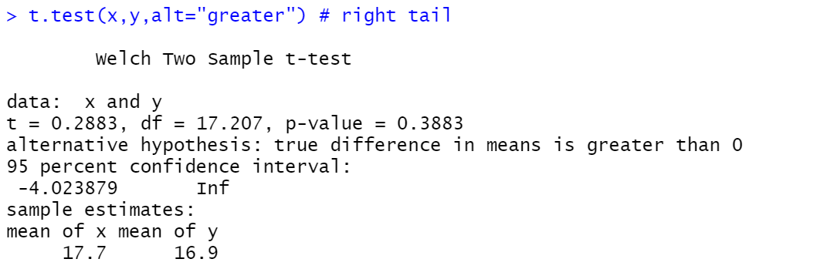



alpha 🡪 0.05  
p_value 🡪 0.3883

p_value>alpha, So H0 is accepted.

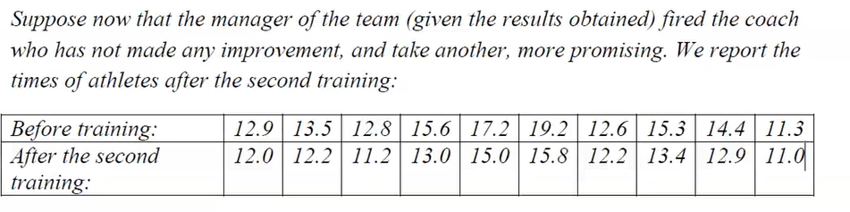3)

H0 : x1bar = x2bar  
H1 : x1bar < x2bar (Left tailed test)

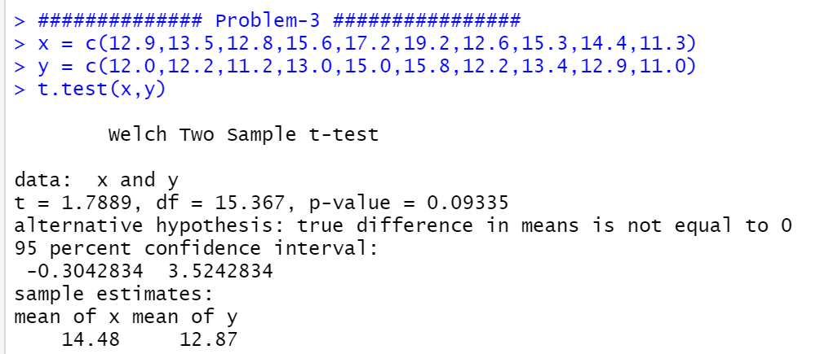  
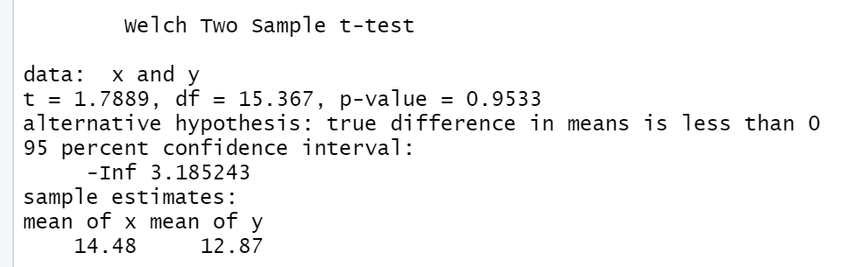



alpha 🡪 0.05  
p_value 🡪 0.9533

p_value>alpha, So H0 is accepted.

**Chi-Square test**





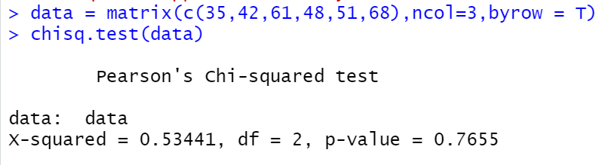

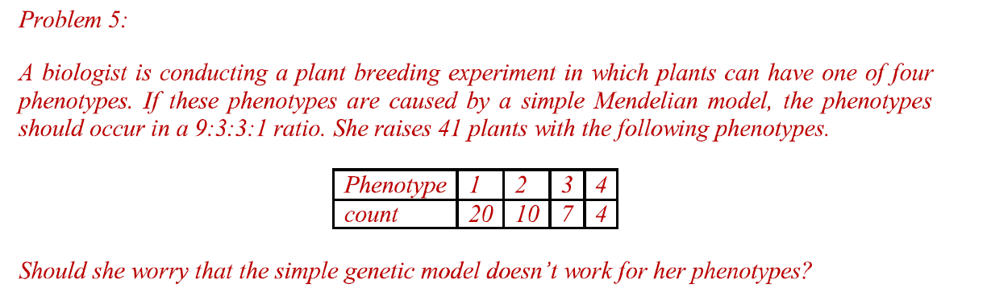



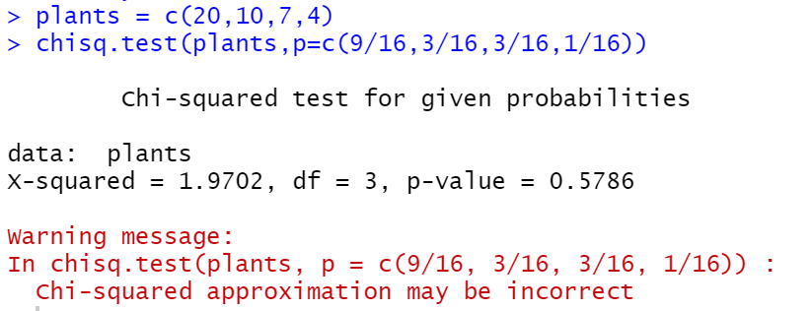

**Binominal Distribution as goodness of fit**

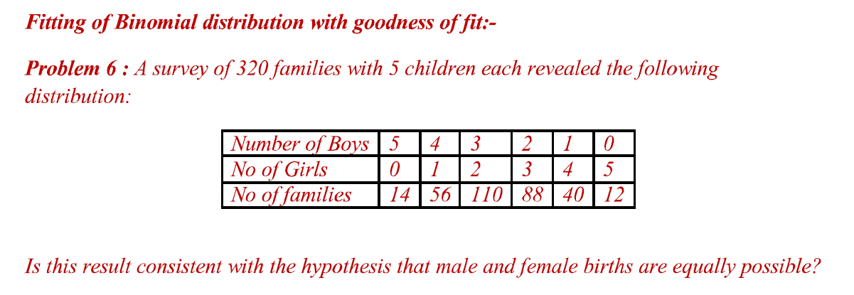



H0 : Binomial distribution is a good fit  
H1 : Binomial distribution is not a good fit

Alpha 🡪 0.05   
df = n-1 🡪 5-1 🡪 4

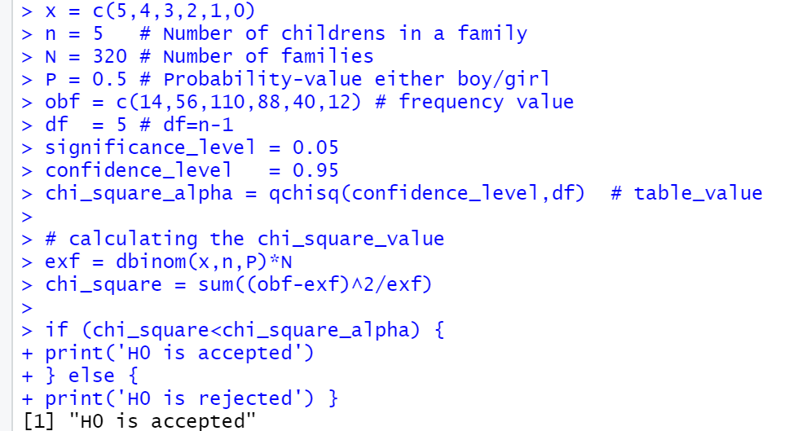

There fore Binominal distribution is a good fit

Problem-7)

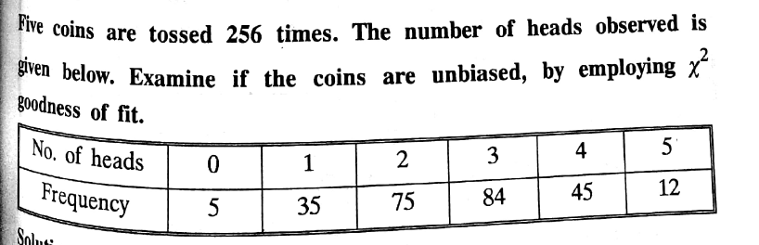

Five_coins 🡪 (n=5)  
observation 🡪 (no=6)  
df = n0-1 🡪 (6-1) 🡪 5

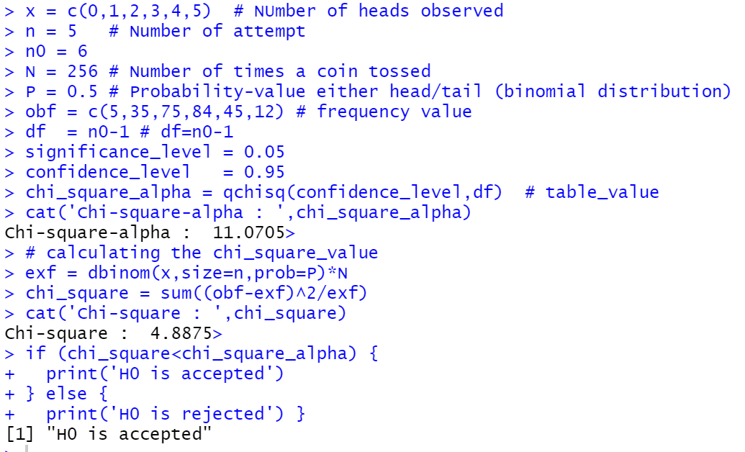

Problem-8)

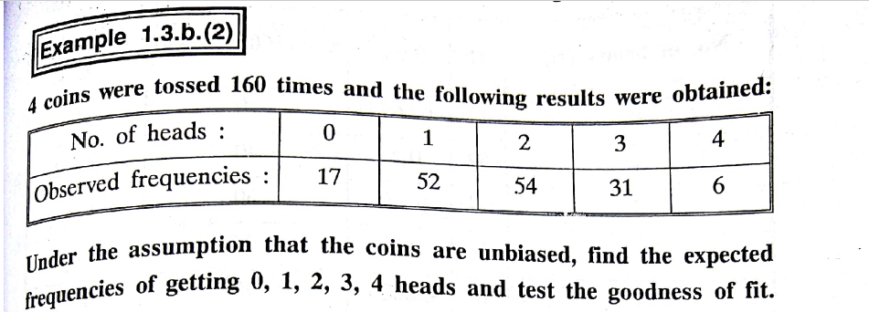

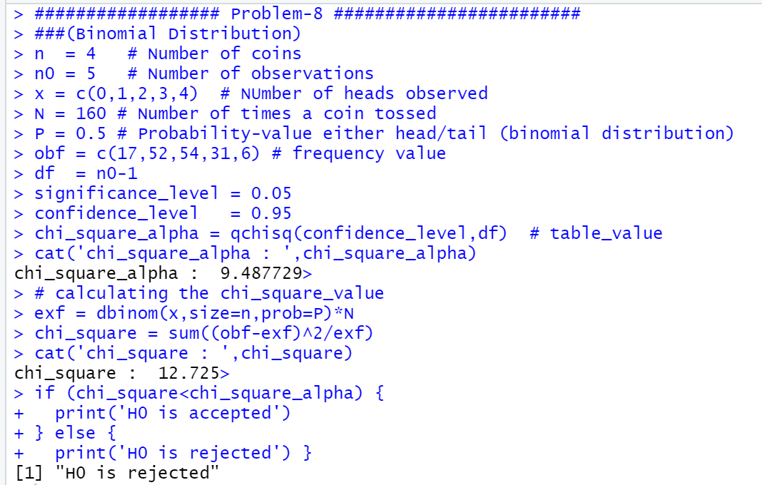

**Poisson Distribution as goodness of fit**

Problem-9)

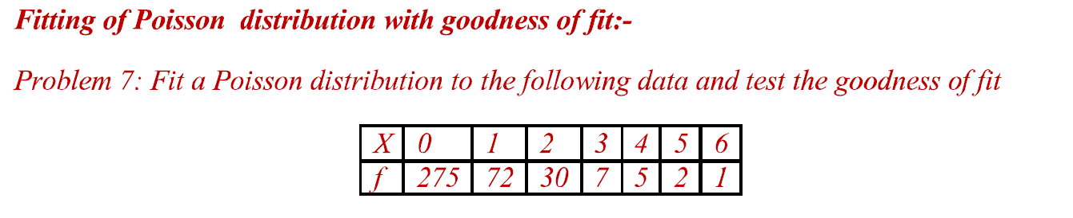

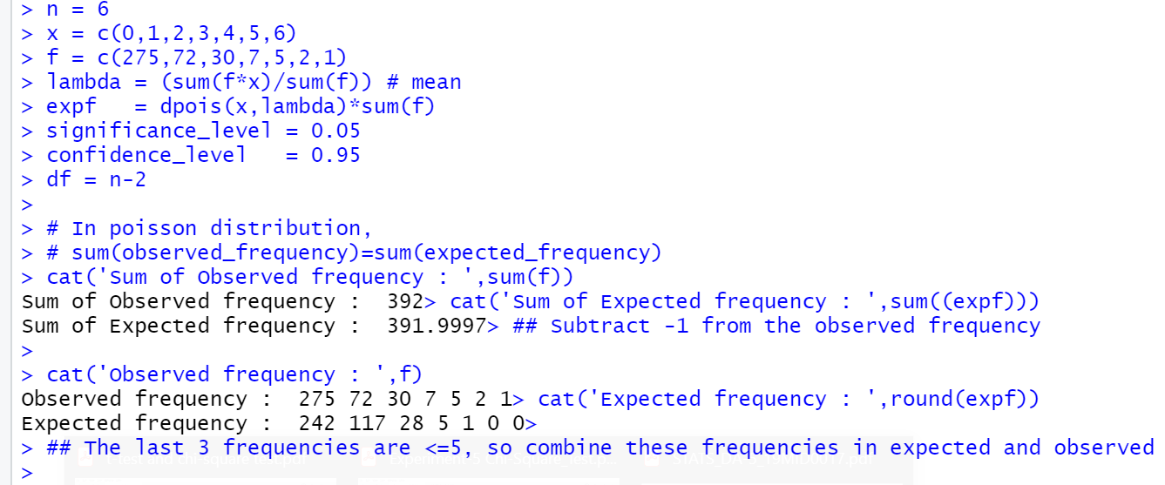  
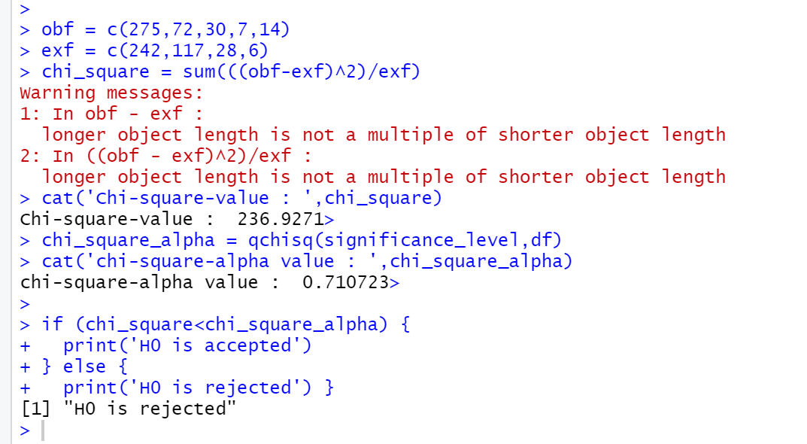

Problem-10)

